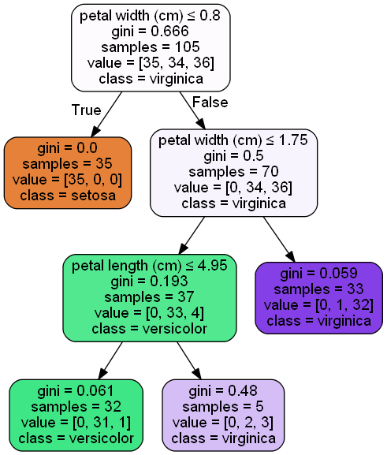

Normal predictions:

[0 1 1 0 0 1 2 1 1 2 2 1 1 1 2 0 1 2 0 2 1 0 1 1 0 0 2 2 2 1 0 2 1 2 0 0 2

0 0 1 2 0 0 1 2]

Actual classes:

[0 1 1 0 0 1 2 1 1 2 2 1 1 1 2 0 1 2 0 2 1 0 1 1 0 0 2 2 2 1 0 2 1 2 0 0 2

0 0 1 2 0 0 1 2]

Normal accuracy:

100.00%

**This tree used our good friend the Iris dataset. No changes were made to the dataset except the max node number was set to 4.**

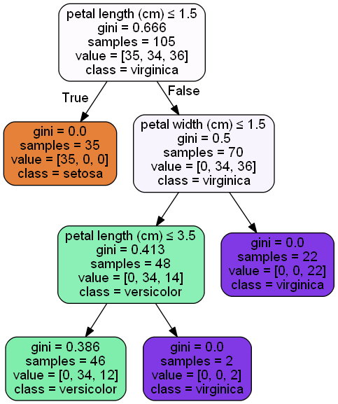

Bin predictions:

[0 1 1 0 0 1 2 1 1 1 1 1 1 1 2 0 1 2 0 1 1 0 1 1 0 0 2 2 2 1 0 2 1 1 0 0 1 0 0 1 2 0 0 1 1]

Actual classes:

[0 1 1 0 0 1 2 1 1 2 2 1 1 1 2 0 1 2 0 2 1 0 1 1 0 0 2 2 2 1 0 2 1 2 0 0 2 0 0 1 2 0 0 1 2]

Binned accuracy:

86.67%

**This tree also used the iris dataset, except the values were binned. This tree is more generalized and wouldn’t be as over-fitted as the first tree.**

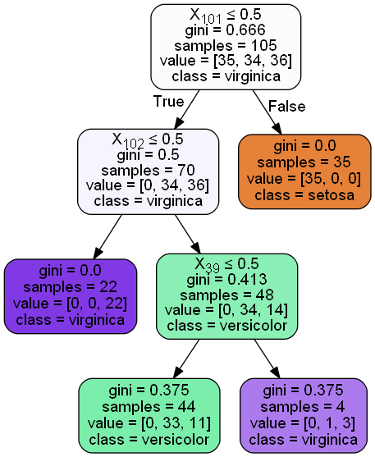

One hot predictions:

[0 1 1 0 0 1 2 2 1 1 1 1 1 1 2 0 1 2 0 1 1 0 1 1 0 0 2 2 2 1 0 2 2 1 0 0 1 0 0 1 1 0 0 2 1]

Actual classes:

[0 1 1 0 0 1 2 1 1 2 2 1 1 1 2 0 1 2 0 2 1 0 1 1 0 0 2 2 2 1 0 2 1 2 0 0 2 0 0 1 2 0 0 1 2]

One hot accuracy:

77.78%

**This tree still used the iris dataset, but a label encoder was applied as well as the one hot strategy.**

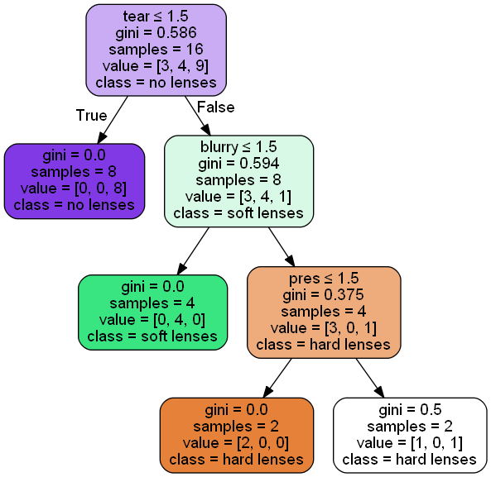

Lense predictions:

[2 3 3 3 1 2 1 3]

Actual classes:

[3 3 3 3 3 2 1 3]

Lense accuracy:

75.00%

**This tree used the lenses dataset. No data was missing and the data was already binned.**

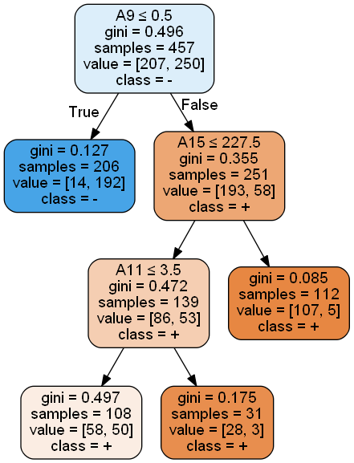

Credit predictions:

['-' '+' '-' '-' '-' '+' '+' '-' '+' '+' '+' '-' '+' '-' '-' '+' '+' '+' '+' '+' '+' '+' '-' '+' '+' '-' '+' '-' '-' '-' '-' '+' '-' '-' '+' '-'

'+' '-' '+' '+' '-' '+' '-' '+' '+' '+' '+' '+' '+' '+' '-' '-' '-' '+' '-' '+' '-' '+' '+' '-' '+' '-' '+' '+' '-' '-' '-' '+' '+' '-' '-' '+'

'-' '+' '-' '+' '-' '-' '-' '-' '-' '+' '+' '+' '-' '-' '+' '-' '-' '-' '-' '+' '+' '-' '-' '+' '+' '-' '+' '-' '-' '-' '+' '+' '-' '-' '-' '-'

'+' '+' '-' '+' '-' '+' '+' '+' '+' '-' '-' '+' '-' '+' '+' '+' '+' '+' '-' '+' '+' '-' '-' '-' '-' '+' '+' '-' '-' '-' '-' '-' '-' '+' '-' '-'

'-' '+' '-' '+' '+' '+' '-' '+' '+' '+' '+' '+' '-' '-' '+' '+' '-' '+' '+' '-' '+' '-' '-' '+' '+' '+' '+' '-' '-' '+' '-' '-' '-' '-' '-' '-'

'-' '-' '+' '-' '+' '+' '-' '+' '-' '+' '-' '-' '+' '-' '+' '+']

Actual classes:

['-' '+' '-' '-' '-' '+' '+' '-' '-' '+' '+' '-' '+' '-' '-' '+' '+' '+' '+' '-' '-' '-' '-' '+' '+' '-' '+' '-' '-' '-' '-' '+' '-' '-' '+' '-'

'+' '-' '+' '+' '-' '+' '-' '+' '+' '+' '+' '+' '+' '-' '-' '-' '-' '+' '-' '-' '-' '+' '+' '-' '+' '-' '+' '+' '-' '-' '-' '+' '+' '-' '-' '+'

'-' '-' '-' '+' '-' '-' '-' '+' '-' '+' '+' '+' '-' '-' '-' '-' '-' '+' '-' '+' '+' '-' '-' '+' '+' '-' '+' '-' '-' '-' '+' '-' '-' '-' '+' '-'

'+' '+' '-' '+' '-' '+' '+' '+' '+' '-' '-' '+' '-' '+' '+' '+' '+' '+' '-' '+' '-' '-' '-' '-' '-' '+' '+' '-' '-' '-' '-' '-' '-' '+' '-' '-'

'-' '+' '-' '+' '+' '+' '-' '+' '+' '+' '-' '+' '-' '-' '+' '+' '-' '+' '+' '-' '+' '-' '-' '+' '+' '+' '-' '-' '-' '+' '-' '-' '-' '-' '-' '-'

'-' '-' '+' '-' '+' '+' '+' '+' '-' '+' '-' '-' '+' '-' '+' '-']

Credit accuracy:

91.33%

**This tree had missing values as well as categorical data. I used the label encoder as well as the one hot strategy, as well as removing missing values to solve those issues.**

**Here is the url to my file:**

A - Some attempt was made

B - Developing, but significantly deficient

C - Slightly deficient, but still mostly adequate

D - Meets requirements

E - Shows creativity and excels above and beyond requirements

**From the above categories I believe I met all the requirements, but I did not do anything to go above and beyond.**